1. pwd command is used to know the current working directory.

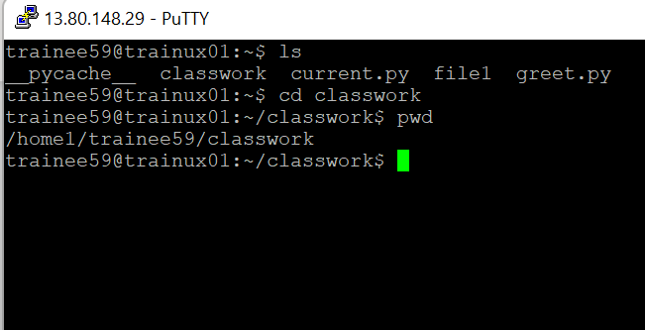

1. 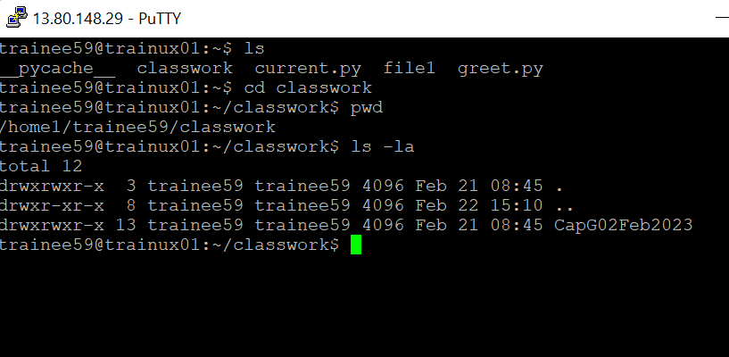ls -la command is used to know its contents.
2. a. mkdir d1

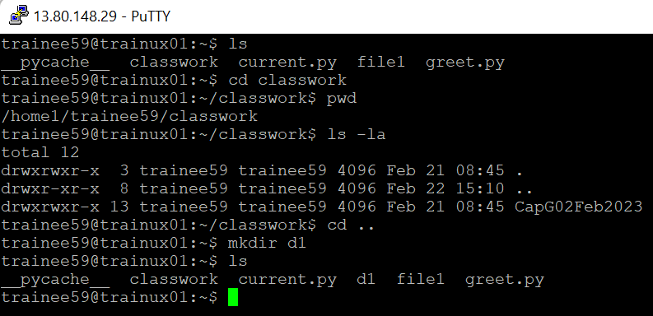

b. mkdir ./d1/d2

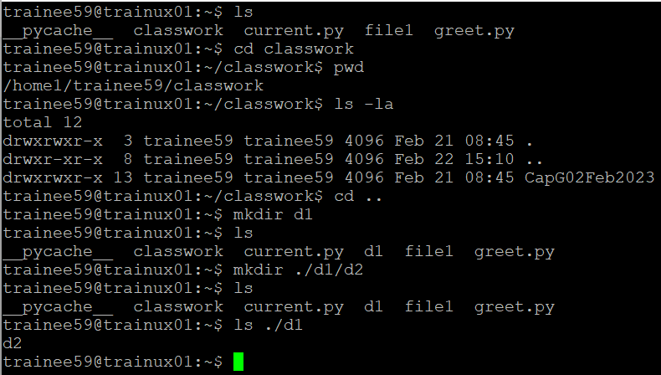

c. cd ./d1/d2/

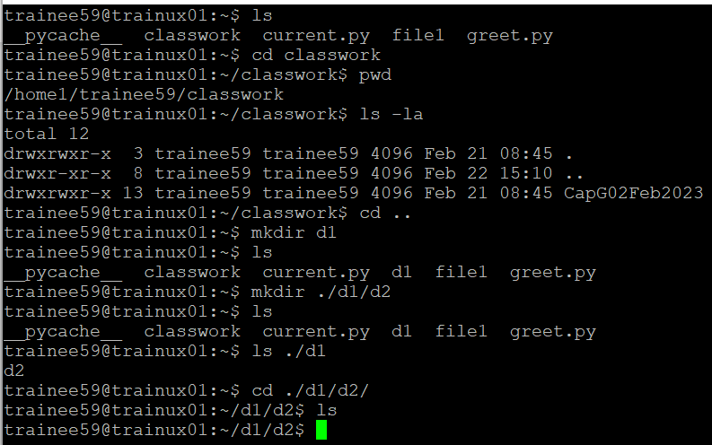

d. touch f1.txt

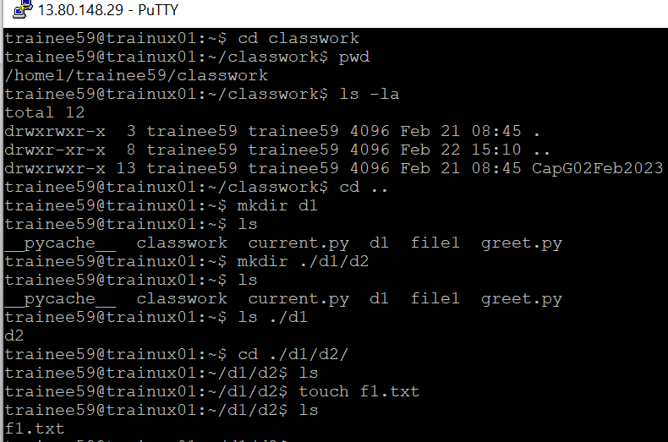

e. cat f1.txt

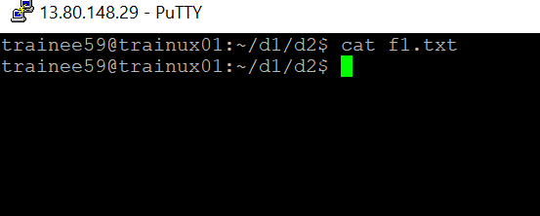

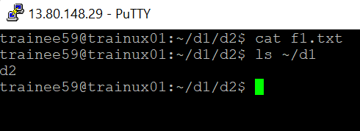 f. ls ~/d1

1. ls -la . We can identify the directory by the symbol “d”.

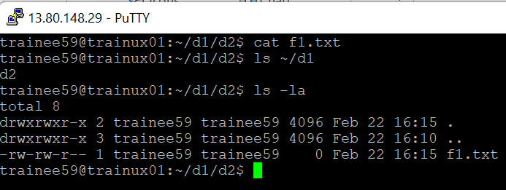

1. a. ls -l ?.\*

b. ls -la

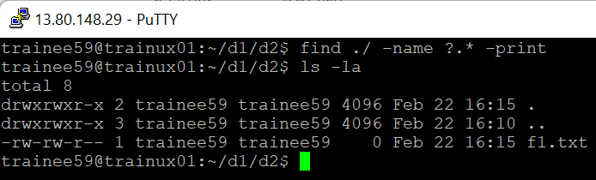

c. ls -l tb[1 2 3 4 5 6 7 8 9 10].1

7. rm temp1 temp2 temp3

8.head -10 greet.py

9.mkdir testdir

10 a. cp tb1.1 ./testdir

b. cp ./tb[1 2 3 4 5 6 7 8 9 10].1 ./testdir/

c. mkdir ./new/new1

d. cp ./tb[2 6 7 10].1 ./new/new1

e. cp -R ./new ./newprogs

11 a. mv command is used to move files and directories as well as to rename a file or directory. Cp command is used to copy file or directory to a different location.

b. rm command is used to remove file as well as directory but rmdir command is used to remove directories.